Intel Corporate Research Council



Intel Corporate Research Council/ University Research Office (URO)

GRANT PROPOSAL COVERSHEET & PRIVACY POLICY NOTICE

Intel is committed to respecting your privacy. The information you provide will be used and retained for processing and funding your grant/gift, for Intel’s audit purposes, and for grant-related correspondence. For more information regarding Intel’s personal information handling practices, please visit www.Intel.com/Privacy.

 (For grants other than conference sponsorships) Check here to certify that you are not
engaged in prior agreements (e.g. government contracts) that constraint your ability to negotiate mutually agreeable intellectual property terms for this grant

(For grants other than conference sponsorships) Check here to notify us that you are
engaged in prior agreements (e.g. government contracts) that constrain your ability to negotiate mutually agreeable intellectual property terms for this grant

Check here to opt in for occasional URO updates - announcements or newsletters

 |  | Proposal Title:
University Name / Receiving Organization |  |  | Department/Discipline
Representative Authorized |  |  | Principal Investigator Information
To Conduct Grant Administration
Contact Name |  |  | PI Name
Mailing |  |  | Mailing Address
Address
Phone # |  |  | Phone #
Fax # |  |  | Fax #
E-Mail |  |  | E-Mail Address
Address
 |  |  | Project /PI URL
 |  |  | Co-Investigator/Students
Amount of
Cash
Requested
Additional
Comments:

Work done so far

As of now, we worked on a generalized detection approach for micro-architectural side-channel attacks by utilizing the hardware performance counters on both Intel and AMD based platforms [1]. We used classification and time-series analysis in our detection scheme.

Recent works [2, 5] in this direction have considered only cache-based attacks for their detection mechanism, neglecting other forms of attacks. Also, the difference between a memory intensive program with the similar code-structure as of an attack process is not clear from their works, i.e., both the works suffer from false positives.

We worked on a generalized approach to learn a classifier with the behaviors of different anomalies (both attack process and non-attack process with similar micro-architectural behavior) in the target system. The classifier gives a warning to the user about the existence of a possible side-channel attack. We dealt with the false positives by correlating the micro-architectural event trace of the abnormal process with the secret key of encryption. Process having a high correlation value is termed as a side-channel attack.

Possible drawbacks

There may be “intelligent” adversaries which perform some random operations in between their work-flow to confuse the detection mechanism. Even the works presented in [2, 5] reported the inability to detect these attacks with their detection scheme, i.e., there is chance of false negatives considering these types of attacks.

Though our approach addresses this issue with the correlation module, the unwanted system noise profoundly hinders this module from accurate detection. The randomness in the process execution makes the detection by the correlation module much harder. Moreover, we need to store the trace of the encryption algorithm for a particular secret key to correlate with the hardware event trace of the abnormal process, which may increase the space complexity of the detection.

Another possible direction

The execution of an “intelligent” adversary consists of attack part added with some random noise part. These adversaries need to execute some particular portion of their code (i.e., the portion responsible for retrieving the secret key) every time to retrieve the secret key successfully. The hardware trace for this part remains same every time of their execution. In the presence of ’forcefully incorporated random code,’ the hardware trace of the actual attack portion will not be affected, rather will be shifted by some interval in the time domain. The Fig.1 gives a basic sketch of this idea for a simulated example.

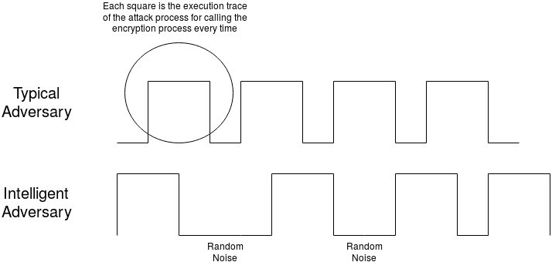
Fig. 1: Work-flow of an “intelligent” adversary

Each square in Fig. 1 represents the execution trace of the adversary for one complete iteration of an encryption algorithm. Typical adversary program accesses the encryption process multiple times in continuation to guess the correct secret key. We have handled these types in our current work. However, an “intelligent” adversary will try to fool the detection scheme by introducing some random operations in between each iteration. These random operations will leave their effects on hardware performance counters, but will not hamper the actual attack portion, as this is necessary for the attacker to mount a successful attack.

We believe all the attack processes have these types of ‘special’ portions in their execution. If we can learn these parts of their executions, then we will be able to detect these attacks even without correlating the traces with the secret key, which is much harder in the presence of system noise.

The execution trace of any hardware event for any adversary process follows a particular temporal pattern as the adversary needs to access the encryption algorithm multiple times to get any information about the secret key as shown in the above figure. These temporal patterns could be learned using Long Short- Term Memory (LSTM) Recurrent Neural Networks [3, 4].

Use of LSTM Networks
LSTMs are special kinds of RNNs capable of learning long-term dependencies in a sequence. The advantage of LSTMs are that they are very generic and does not require any feature engineering beforehand, i.e., we need to select any important feature for the decision. We know, the hardware trace of an adversary process is a temporal sequence of different hardware events and to become successful the adversary needs to execute the ‘attack’ portion of the code. Thus, in the presence of a random noise for a random interval of time there exist a dependency in the sequence of values of the hardware events for the adversary process to become a successful attack. This, we believe, is a perfect scenario for the application of an LSTM networks.

Possible way to approach

We may approach this problem in the following ways:
- We don’t have access to the “intelligent” attack codes, but we do have access to most of the typical micro-architectural attack codes. We can incorporate random operations in between them and see whether they are retrieving the correct secret keys or not. If they become successful in recovering the secret key, we can use them as our test cases.

- Once the test cases are formed, we can use our current detection mechanism and see whether they are detected or not. (I believe they will not be detected with high amount of random operations in the presence of system noise, but I need to check).

- If we can detect these modified attack codes with the current approach, we can add more randomness without hampering its successful retrieval of keys. Otherwise, we can generate the hardware traces of these attack processes and learn an LSTM network with them.

- Since we are modifying the attack codes by ourselves, we know which por- tion of the code is actual attack code and which are random noise. This information will help the LSTM network to learn the behavior accurately.

There are two forms of noise: one coming from other system programs, and another coming from introduction of different “intelligent codes”, in the attack code itself. We can generate multiple instances of attack traces incorporating a combination of these types of attacks. For example, for intelligent codes, we can add random sleeps, or random memory reads of large chunks so that they affect cache, etc. similarly we can run different background programs, e.g. browsers, video encoders, compression algorithms, data processing tools, etc to generate different system noises. Our task is to classify all these noisy attack traces as positive, when compared to non-attack traces. We can take some of these noisy attack traces as training data and the rest as test data, and try to classify using LSTM, vs the existing methods.

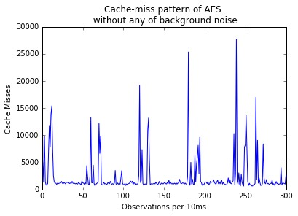 | 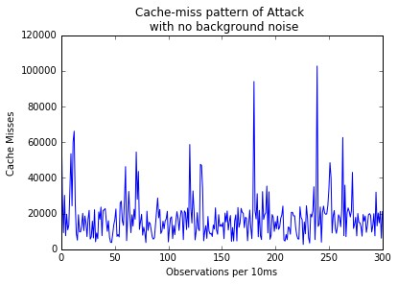 | 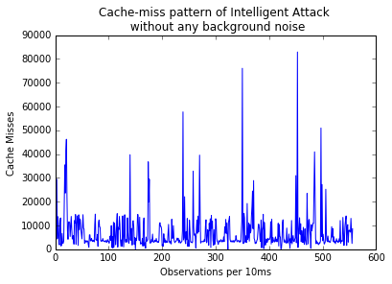
Cache Miss trace of AES encryption for a particular secret key. | Cache Miss trace of conventional cache-timing attack on AES | Cache Miss trace of modified intelligent attack on AES
Fig. 2: Temporal Sequences of different scenarios in the absence of background noise.

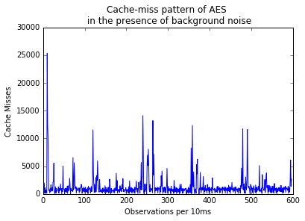 | 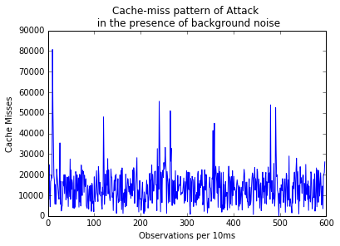 | 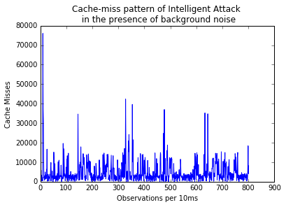
Cache Miss trace of AES encryption for a particular secret key. | Cache Miss trace of conventional cache-timing attack on AES | Cache Miss trace of modified intelligent attack on AES
Fig. 3: Temporal Sequences of different scenarios in the presence of background noise.

References

- Alam, M., Bhattacharya, S., Mukhopadhyay, D., Bhattacharya, S.: Performance counters to rescue: A machine learning based safeguard against micro-architectural side-channel attacks. IACR Cryptology ePrint Archive 2017 (2017) 564

- Chiappetta, M., Savas, E., Yilmaz, C.: Real time detection of cache-based side- channel attacks using hardware performance counters. Appl. Soft Comput. 49 (2016) 1162–1174

- Hochreiter, S., Schmidhuber, J.: Long short-term memory. Neural Computation 9(8) (1997) 1735–1780

- Olah, C.: Understanding lstm networks (Aug 2015)

- Zhang, T., Zhang, Y., Lee, R.B.: Cloudradar: A real-time side-channel attack de- tection system in clouds. In: Research in Attacks, Intrusions, and Defenses - 19th International Symposium, RAID 2016, Paris, France, September 19-21, 2016, Proceedings. (2016) 118–140

